Katie Monnin, PhD, is an assistant professor of literacy at the University of North Florida and author of Teaching Graphic Novels: Practical Strategies for the Secondary ELA Classroom (2010) from Maupin House. To learn more about Teaching Graphic Novels or Katie Monnin, please go to this link: http://www.maupinhouse.com/monnin.php
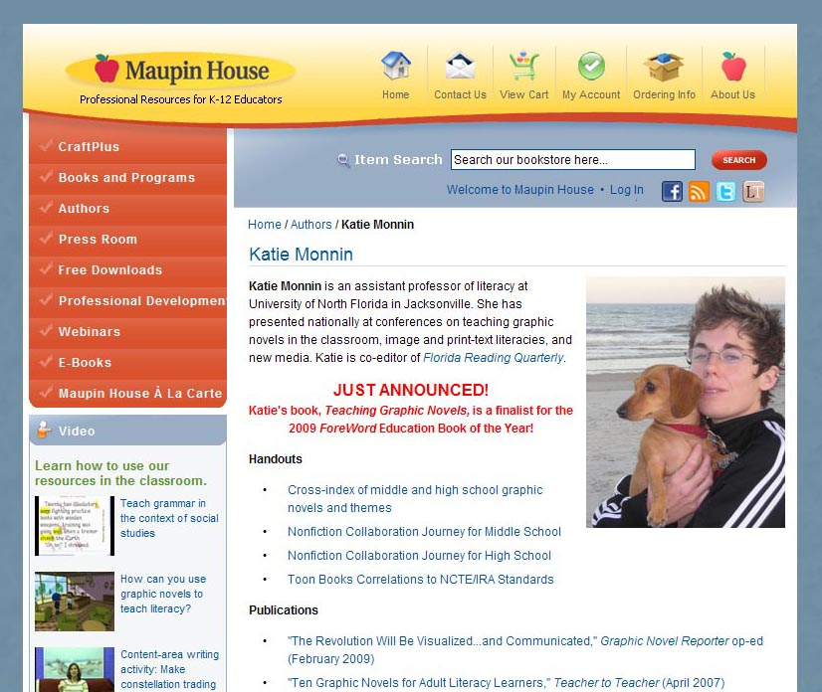
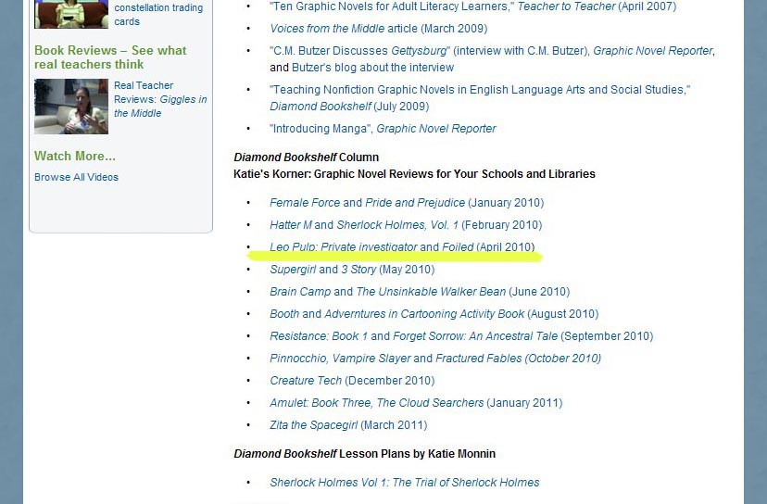
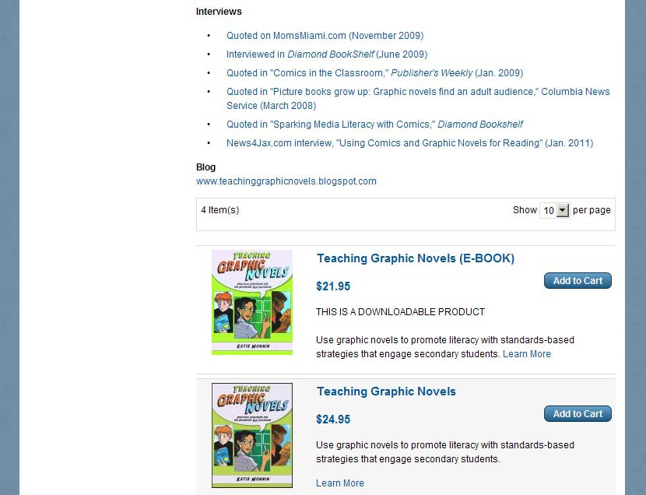
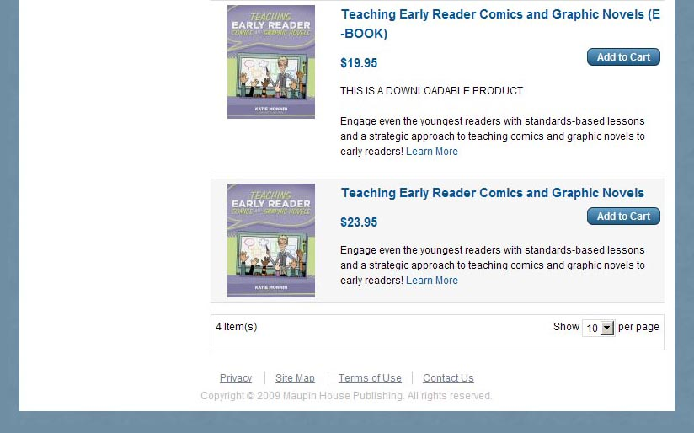

***************************************************
ORIGINALE

Da: http://translate.google.it/translate?hl=it&sl=en&tl=it&u=http%3A%2F%2Fwww.diamondbookshelf.com%2Fpublic%2Fdefault.asp%3Ft%3D1%26m%3D1%26c%3D20%26s%3D162%26ai%3D99938

Lesson Plans

Leo Pulp: Private Investigator
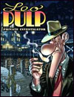
Leo Pulp: Private Investigator
Lesson plan by Dr. Katie Monnin
Written originally in 2000 by Italian writer Claudio Nizzi and Italian artist Massimo Bonfatti Leo Pulp: Private Investigator is one of the most creative and engaging graphic novel stories I have ever read. Reprinted in graphic novel format by IDW in 2009, Leo Pulp is a graphic novel of satirical and comic genius. Paying homage to the popular pulp crime fiction of the 1940s, readers find the main character, Leo Pulp, a detective who works for $25 a day, plus expenses. And what does this $25 a day earn his clients? Besides a detective with a hound-like nose for sniffing out the bad guys and figuring out their motives, Leo not only solves crimes, but also manages to be a debonair showman while doing so.
A want-to-appear-tough-guy who never backs down, readers find themselves laughing, cheering and loving Leo through each of his cases. Someone who does not always cheer for Leo, however, is the local chief of police. In fact, while the pairing of local lawman with underground private investigator might at first seem antagonistic, it is – cliché aside – actually somewhat of “a match-made-in-heaven.” Besides the chief of police, readers will find another engaging character in Leo's love interest, Norma, an owner of a local diner who always seems to know just what Leo wants.
Leo, the chief of police, and Norma can each be found in the three stories reprinted by IDW in 2009, and, if I were you, I wouldn't loose one more minute trying to find a copy. Leo Pulp is a must read, a must see, and a must teach graphic novel.
English Language Arts Elements of Story
Plot: Three individual cases that detective Leo Pulp is hired – by clients who do not wish to involve the police – to solve
Setting: 1940s Hollywood
Characters: Leo Pulp, Nick (“Dick”) Tracy, Norma, some bad guys and some good guys, and even some bad girls and some good girls are all in the mix
Themes: Crime-solving, 1940s Hollywood, Fact & Fiction, Honesty & Lies, Comedy
Traditional Literature/Author Pairing Suggestions: Arthur Conan Doyle's Sherlock Holmes , Edgar Allen Poe's The Murder's in the Rue Morgue , Edward Stratemeyer's The Hardy Boys or Nancy Drew , Agatha Christie's And Then There Were None , Raymond Chandler's Lady in the Lake , Charles Dicken's The Mystery of Edwin Drood
Some Teaching Recommendations For Middle School & High School English Language Arts
Suggested Alignment to the IRA /NCTE Standard(s):*
- standard #s correspond to the numbers used by IRA/NCTE
1. Students read a wide range of print and nonprint texts to build an understanding of texts, of themselves, and of the cultures of the United States and the world; to acquire new information; to respond to the needs and demands of society and the workplace; and for personal fulfillment. Among these texts are fiction and nonfiction, classic and contemporary works.
2. Students read a wide range of literature from many periods in many genres to build an understanding of the many dimensions (eg, philosophical, ethical, aesthetic) of human experience.
3. Students apply a wide range of strategies to comprehend, interpret, evaluate and appreciate texts.
Suggested Reading Strategies:
- If students are asked to read Leo Pulp alongside a traditional literary mystery / crime fiction text, it may be helpful to ask them to complete two timelines, one for each text. First, on their own or in pairs, students draw out and label some rough ideas of what they think should be on the timelines. Then, as a class, ask students to share and discuss their ideas. Ultimately, the class should decide upon the major events that will go on the two timelines; such critical discussions will help strengthen student comprehension of both texts.
- Building upon the two timelines, students can next fill out a Venn Diagram reading strategy, which asks them to compare and/or contrast the two texts.
- If you would like to next transition students to a writing activity, you can ask them to transition their timelines and Venn diagrams into a compare and/or contrast essay. “What,” you can ask them, “do the crime/mystery texts have in common? And, where do they differ?”
*NCTE/IRA. (1996). Standards for the English Language Arts . Urbana, IL: NCTE.
Katie Monnin, PhD, is an assistant professor of literacy at the University of North Florida and author of Teaching Graphic Novels: Practical Strategies for the Secondary ELA Classroom (2010) from Maupin House. To learn more about Teaching Graphic Novels or Katie Monnin, please go to this link: http://www.maupinhouse.com/monnin.php .

